Hybrid Topology

What Is Hybrid Topology?
# Source: AI Source: Provided by: [Data Path: Persons Table -> ID Column: 1, Name_En Column: Motasem Essam] -> From: [ChatGPT] on [12/18/2025]
A Hybrid Topology is a combination of two or more different types of network topologies (like star, mesh, ring, or bus) to create a flexible, scalable, and efficient network structure.

🧠 Simple Definition:
# Source: AI Source: Provided by: [Data Path: Persons Table -> ID Column: 1, Name_En Column: Motasem Essam] -> From: [ChatGPT] on [12/18/2025]
A Hybrid Topology blends multiple network layouts into a single design to leverage the advantages of each and minimize their weaknesses.

🖼️ Visual Example
# Source: AI Source: Provided by: [Data Path: Persons Table -> ID Column: 1, Name_En Column: Motasem Essam] -> From: [ChatGPT] on [12/18/2025]
Imagine a network where:
- A star connects office PCs,
- A ring connects core switches between departments,
- A mesh connects critical servers.
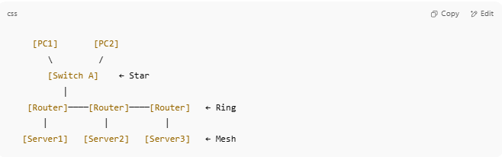
[PC1] [PC2]
\ /
[Switch A] ← Star
│
[Router]────[Router]────[Router] ← Ring
│ │ │
[Server1] [Server2] [Server3] ← Mesh

🔧 Examples of Hybrid Topologies
# Source: AI Source: Provided by: [Data Path: Persons Table -> ID Column: 1, Name_En Column: Motasem Essam] -> From: [ChatGPT] on [12/18/2025]
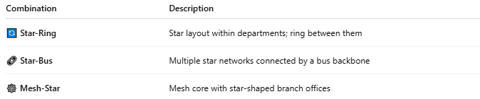

Combination | Description
🔄 Star-Ring | Star layout within departments; ring between them
🔗 Star-Bus | Multiple star networks connected by a bus backbone
🕸 Mesh-Star | Mesh core with star-shaped branch offices

✅ Advantages
# Source: AI Source: Provided by: [Data Path: Persons Table -> ID Column: 1, Name_En Column: Motasem Essam] -> From: [ChatGPT] on [12/18/2025]
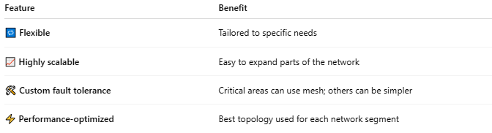

Feature | Benefit
🔁 Flexible | Tailored to specific needs
📈 Highly scalable | Easy to expand parts of the network
🛠️ Custom fault tolerance | Critical areas can use mesh; others can be simpler
⚡ Performance-optimized | Best topology used for each network segment

❌ Disadvantages
# Source: AI Source: Provided by: [Data Path: Persons Table -> ID Column: 1, Name_En Column: Motasem Essam] -> From: [ChatGPT] on [12/18/2025]
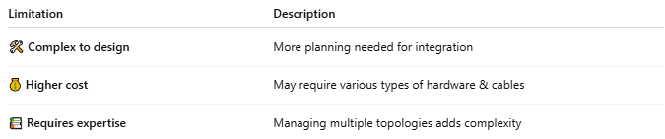

Limitation | Description
🛠️ Complex to design | More planning needed for integration
💰 Higher cost | May require various types of hardware & cables
📚 Requires expertise | Managing multiple topologies adds complexity

🏢 Common Use Cases
# Source: AI Source: Provided by: [Data Path: Persons Table -> ID Column: 1, Name_En Column: Motasem Essam] -> From: [ChatGPT] on [12/18/2025]
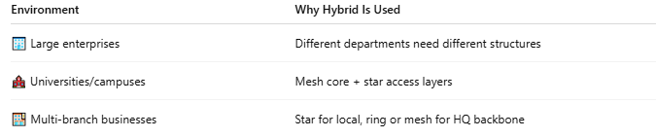

Environment | Why Hybrid Is Used
🏢 Large enterprises | Different departments need different structures
🏫 Universities/campuses | Mesh core + star access layers
🏬 Multi-branch businesses | Star for local, ring or mesh for HQ backbone

✅ Summary
# Source: AI Source: Provided by: [Data Path: Persons Table -> ID Column: 1, Name_En Column: Motasem Essam] -> From: [ChatGPT] on [12/18/2025]
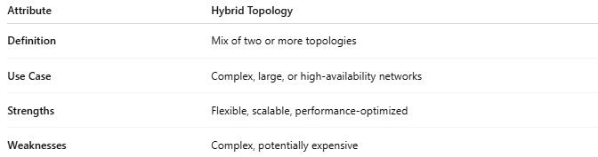

Attribute | Hybrid Topology
Definition | Mix of two or more topologies
Use Case | Complex, large, or high-availability networks
Strengths | Flexible, scalable, performance-optimized
Weaknesses | Complex, potentially expensive

